Math 10

Lesson 4–1 Answers

**Lesson Questions**

**Question 1**



rise = 9

rise = –3

run = 6

run = 8



**c)**



**Question 2**

Draw the following line segments:

–8

4

8

–8

–4

4

8

–4

*x*

*y*

●

●

**a**

●

●

**b**

a) Beginning at point (–3, –2) and with a slope of  .

b) Beginning at point (2, 3) and with a slope of  .

**Question 3**

a)



b) The slope represents the number of dollars he earns per hour.

c)

i) ii)



**Assignment**

1. a) Negative

b) Positive

c) Not defined

d) Zero

2. a) Rise: 3; run: 6; slope: 

b) Rise: –2; run: 8; slope: 

c) Rise: 3; run: 4; slope: 

d) Rise: –6; run: 2; slope: –3

3. a) 3

b) 

c) 

d) 

4. Sketches may vary. The line segments may have different lengths but they should have the same orientations as those shown.

 a) b) c) d)

5. a) 

b) 

c) The slopes in parts a and b are equal.

6. a) i) 2 ii)  iii) –3 iv) 

b) i) As *x* increases by 1, *y* increases by 2.

ii) As *x* increases by 2, *y* increases by 1.

iii) As *x* increases by 1, *y* decreases by 3.

iv) As *x* increases by 3, *y* increases by 1.

7. a) 

b)  in.

8. a) 

b) 312 in., or 26 ft.

c)  in.

9. a) i)  ii)  iii)  iv) 

b) The slopes of BC and ED are equal. The slopes of BE and CD are equal. The two different slopes are opposites.

10. a) 

11. Coordinates may vary. For example:

a) (–4, 5), (–6, –3), (–7, –7)

b) (–7, 3), (–3, –1), (–1, –3)

c) (–8, 2), (–2, 0), (1, –1)

d) (–1, 8), (–9, –6), (–13, –13)

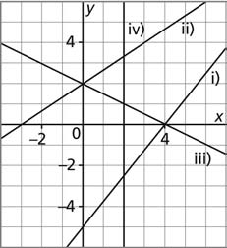

12. a) i) Positive

ii) Positive

iii) Negative

iv) Not defined

b) Sketches may vary. For example:

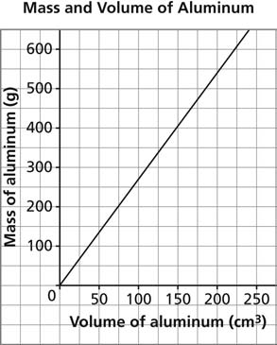

13. a)

b) 2.7 g/cm3

c) The slope shows that for every 1 cm3 increase in the volume of an aluminum cube, the mass of the cube increases by 2.7 g.

d) i) 135 g

ii) 742.5 g

e) i) Approximately 37 cm3

ii) Approximately 167 cm3

14. a) The number of text messages is restricted to whole numbers.

b) $0.15, or 15¢

c) $4.95

d) 48 text messages

e) Assumptions may vary. For example: I assumed that all messages cost the same.

15. a) $45/month

b) $505

c) $55

d) Assumptions may vary. For example: I assumed that Charin continues to save the same amount each month after the 5th month and that the savings account did not earn any interest.

16. a) 2 b) 

17. No